BM 538

Computational Neuroscience

Project:

Posner Paradigm

Experimentor:

Kerem Kurban

Submitted to:

Burak Güçlü

Sevgi Öztürk

Experiment Dates:

29.09.2017 - 6.10.2017

**Results**

There was still a problem with the test, if only one button is used, a bias is formed such that the subject will press when he sees the target. Therefore a cue without target epochs are necessary to prevent that from happening.

* It can be seen that 100 ms delay takes significantly longer time p = 0 than 300ms delay which is expected because the processing in the brain takes a little more time after the 100ms delay, hence increase in RT.

Mean of 100 ms delay = 0.9481 sec

Mean of 300 ms delay = 0.8212 sec

* Mean Reaction Time differece of valids and invalids is not significant p=0.29, but there is a slight delay in invalids in terms of RT.

Mean of valids = 0.8766 secs

Mean of invalids = 0.8928 secs

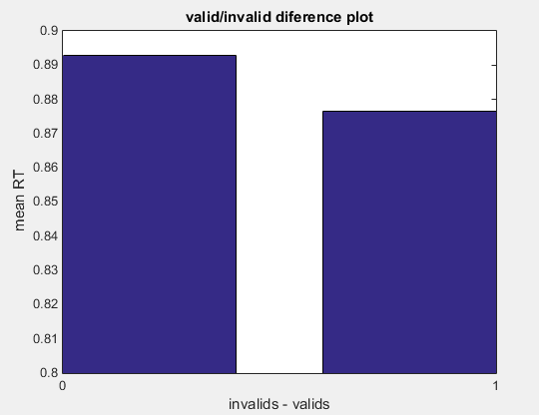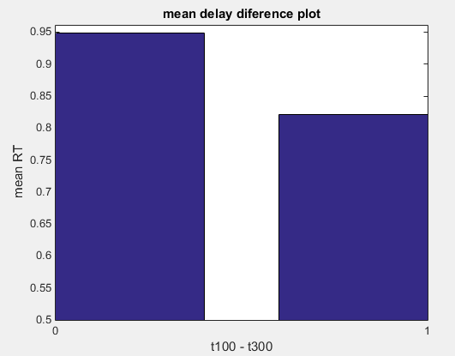

Figure 1 : Bar plots of valid/invalid (left: invalid, right: valids) and delays (left 100ms , right 300ms)

* Reaction times increased as horizontal or vertical distances increased with respect to fixation point in invalid cases with p=0.6484 for 2 sample t test hence difference is not significant.
* We can see that the curvature changes around dist = 5 which indicates upto a certain distance reaction time decreasingly changes until a certain thresold where it RT now exponentially increases as the distance magnifies. This could be an artifact due to small sample size.
* Euclidian speed = 6.684 units/sec considering the size of 17.3 inch screen.
* Horizontal speed = 4.374 units/sec
* Vertical speed = 4.3429 units/sec

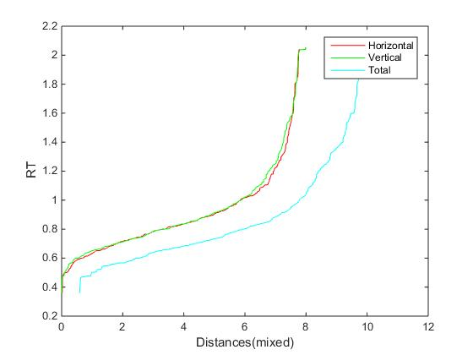

Figure 2: Distance vs. Reaction times for horizontal, vertical and euclidian distances.